**NATO outpost in Afghanistan**

*Simulation game for 4-8 people*

**Contents**

Overall situation (preliminary information for students) 3

Situation 4

Answer Sheet 7

Completed answer sheet (scenario with no risc) 8

# Overall SITUATION (preliminary information for students)

You are a sergeant of a small NATO outpost. This outpost is in region surrounding the city of **Fayzabad, Afghanistan,** as part of the operation “Resolute Support” You are specialized in the destruction of unexploded ordnance. The people involved in the operation are:

* you;
* your friend Miller, who represents a well-known western media outlet;
* colonel Stevenson – a 55 year old, exceptional specialist in the field of local traditions, who spends his free time on studying local history;
* captain Stuart from intelligence department;
* corporals, Wulf and Adamson, unexploded ordnance experts, who are in charge of training the local security forces;
* Abdullah – translator, well known for his good heart and a quad bike that has no equivalents in the entire region.

The local conditions are rough so colonel Stevenson, you and corporal Wulf has access to radio communication. Though you can only communicate between yourselves and a helicopter pilot named **Jim, from the local aviation school**.

* NATO outpost has a HUMVEE and a quad bike with a trailer.
* You have no additional people or any other communication equipment.
* You are in safe territory that is not under military threat, but movement is only possible on the river, the roads or air.
* Speed of the HUMVEE: 60km/h on the highway, 25km/h on mountain trails. Capacity – 5 people, including the driver. No trunk.
* Speed of the quad bike – 40km/h on both, the highway and mountain trails. Capacity – 1 person and one piece of equipment (medicine or batteries).
* MEDEVAC aircraft: within 1 hour can reach either the airfield near the crossing or a field halfway to the village.
* Helicopter has two seats.
* Box of batteries takes up one space in any form of transport.
* River crossing takes 45 minutes in one direction.

# SITUATION

**The clock is ticking. You have 20 minutes to make your decisions. Time: 12.00**

You are a sergeant of a small NATO outpost. This outpost is in region surrounding the city of **Fayzabad, Afghanistan,** as part of the operation “Resolute Support”. You are specialized in the destruction of unexploded ordnance. The people involved in the operation are:

* you;
* your friend Miller, who represents a well-known western media outlet;
* colonel Stevenson – a 55 year old, exceptional specialist in the field of local traditions, who spends his free time on studying local history;
* captain Stuart from intelligence department;
* corporals, Wulf and Adamson, unexploded ordnance experts, who are in charge of training the local security forces;
* Abdullah – translator, well known for his good heart and a quad bike that has no equivalents in the entire region.

On a Friday’s morning you have decided to take a rest at the base camp so that later you can escort Miller who will return to his wife in Europe. His wife is having premature childbirth, so he must depart **from the Fayzabad city airport at 16.55**, this evening.

Colonel Stevenson together with captain Stuart have gone off to a town 35km away to investigate intelligence about possible weapon contraband. Corporals Wulf and Adamson are headed off on the **Kocha river to a communication tower**, 15km away. They are going there to check on construction work. The boat is quite fast – 20km/h, so they should not be gone for long.

The local conditions are rough so colonel Stevenson, you and corporal Vulf has access to radio communication. Though you can only communicate between yourselves and a helicopter pilot named **Jim, from the local aviation school**. Jim works only half an hour flight time away from your position. He is a regular guest at your exercise outpost since it gives him a chance to rest during the two-hour flight from Fayzabad to the aviation school.

You are trying to master the Afghan language, that Abdullah knows well. You are both talking about a river, that throughout centuries has helped to develop two different communities that are connected only by a river crossing. **This crossing can be reached in only 30 minutes by a quad bike**, using mountain trails. Abdullah is proud that through a local study programme he has completed a radio telephone course. Starting from next week, he will begin his job as a radio operator at the crossing. His father is already working there as a ferryman. **A fancy office has been built at the other side of the crossing** and it is equipped with top-tech radio equipment that allows for communication with the city of Fayzabad. He has brought and set up the equipment by himself. He did it by using an old HUMVEE that has now been handed off to the outpost. The car is old, but i**t can still do the highway trip, from Fayzabad to the intersection where mountain trails to outpost and highway meet, in 1 hour and 15 minutes**.

**At 12.25** you get a call from colonel Stevenson. He has experienced a tire blowout at the border of the town. Though the intel about weapons contraband was false, an improvised explosive device was discovered in the town center. It is controlled by mobile communication, that is currently being counteracted by captain Stuart’s communication suppression device. The town has been successfully evacuated so **lives are not at danger**. However, the battery on captain’s device **will run out in 3.5 to 4 hours**. There is a risk that the explosive might destroy a local mosque, doing big damage to the local population of poor people. To completely neutralize the explosive**, two additional helpers are needed**.

While you are packing up batteries into the HUMVEE, Abdullah runs up to you**. He says** that his sister has been bitten by a venomous snake. She only **has 4 hours left to live**, unless help arrives beforehand. Thankfully, there is an antidote available. However, it is only available in the city of Fayzabad. With even Abdullah at the wheel it could only be reached in no less than 4 hours, 51 minutes. Abdullah tells that it is possible to call a MEDEVAC aircraft.

**Within an hour** it could land at either the other side of the crossing or on a field halfway to the town in which Stevenson is located. **Requesting MEDEVAC would require radio equipment that is only available either at the crossing or at the aviation school**. At the end of the talk, you receive a message from Wulf who says that the boat engine is malfunctioning, so **their speed is now limited to 10km/h.**

You get in contact with Jim, but **he is one and a half hours away from the aviation school** where the radio equipment is located. After landing at the aviation school, he needs to refuel. If you push the power of the old pump to the max, you can do it in half of a standard time. However, **there is 50% risk that pump will broke**.

**At that point Miller runs up to remind you that he must get to the airport**.

**The clock is ticking. You have 20 minutes.**

**WHAT WILL YOU DO?**

**Characteristics:**

* NATO outpost has a HUMVEE and a quad bike with a trailer.
* The people at the NATO outpost are You, Miller, Abdullah and his sister.
* You have no additional people or any other communication equipment.
* You are in safe territory that is not under military threat, but movement is only possible on the river, the roads or air.
* **Speed of the HUMVEE: 60km/h on the highway, 25km/h on mountain trails. Capacity – 7 people, including the driver. No trunk.**
* **Speed of the quad bike – 40km/h on both, the highway and mountain trails. Capacity – 1 person and one piece of equipment (medicine or batteries).**
* **MEDEVAC aircraft: within 1 hour can reach either the airfield near the crossing or a field halfway to the village where Stevenson is located.**
* **Helicopter has two seats.**
* **Box of batteries takes up one space in any form of transport.**
* **Speed of the helicopter refuel with two helpers takes 90 minutes standard. Boosted pump can do it in 45 minutes, but in this case there is 50% possibility that pump will broke.**
* 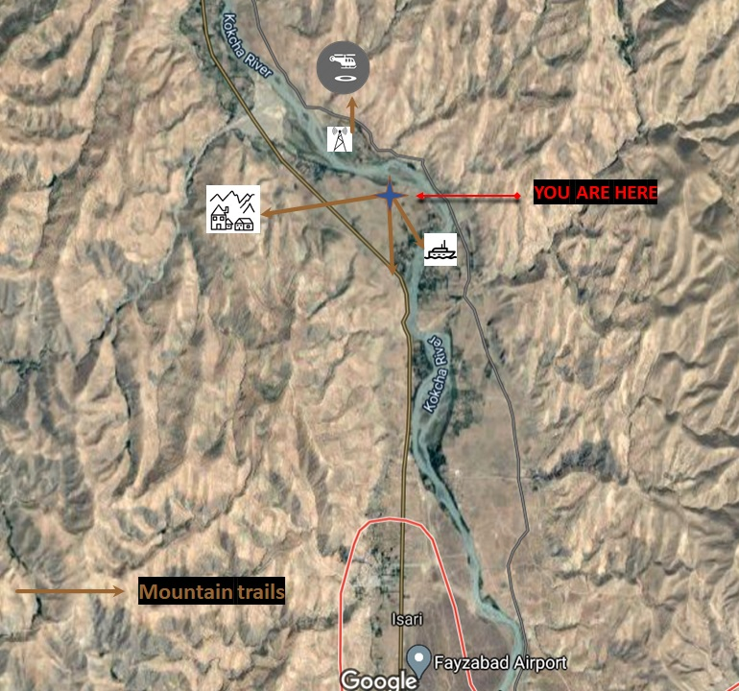**River crossing takes 45 minutes in one direction.**

# Answer Sheet

|  |  |  |  |  |
| --- | --- | --- | --- | --- |
| Order of action | | | | |
|  | OBJECTIVE | Available Time | Needed equipment | Result (Done/Not done) |
| Priority 1 |  |  |  |  |
| Priority 2 |  |  |  |  |
| Priority 3 |  |  |  |  |

|  |  |  |  |  |  |  |
| --- | --- | --- | --- | --- | --- | --- |
| FLF Simulation game. Group -_____ (Insert number) | | | | | | |
|  | Action | Vehicle used | Persons/equipment in vehicle | Route from | Route to | Time spent |
| Step 1 |  |  |  |  |  |  |
| Step 2 |  |  |  |  |  |  |
| Step 3 |  |  |  |  |  |  |
| Step 4 |  |  |  |  |  |  |
| Step 5 |  |  |  |  |  |  |
| Step 6 |  |  |  |  |  |  |
| Step 7 |  |  |  |  |  |  |
| Step 8 |  |  |  |  |  |  |
| Step 9 |  |  |  |  |  |  |
| Step 10 |  |  |  |  |  |  |
| Step 11 |  |  |  |  |  |  |
| Step 12 |  |  |  |  |  |  |
| Step 13 |  |  |  |  |  |  |
| Step 14 |  |  |  |  |  |  |
| Step 15 |  |  |  |  |  |  |
| Step 16 |  |  |  |  |  |  |

# completed answer sheet (scenario with no risc)

|  |  |  |  |  |  |
| --- | --- | --- | --- | --- | --- |
| Order of action | | | | | |
|  | OBJECTIVE | Available Time | Needed equipment | Result (Done/Not done) | Time spent |
| Priority 1 | Save lives | 4h | MEDEVAC | DONE | 2h33min |
| Priority 2 | Save infrastructure | 3h30 min-4h | 2 persons, battery pack | DONE | 3h |
| Priority 3 | Get person to the airport | 4h 30min | NONE | DONE | 4 h 7 min 30 sec |

|  |  |  |  |  |  |  |  |
| --- | --- | --- | --- | --- | --- | --- | --- |
| FLF Simulation game. Group -_____ (Insert number) | | | | | | | |
|  | Action | Vehicle used | Persons/equipment in vehicle | Route from | Route to | Time spent | Notes |
| Step 1 | Take girl to the crossing | HUMVEE | Girl, Abdullah, me. | Base | River crossing | 48 min | Girl is left on the left side of the river. She will be ferried to the other side by Abdullah’s father and Abdullah |
| Step 2 | Call back Wulf and Adamson | Radio |  |  |  |  | Wolf and Adamson needs 90 minutes to get back |
| Step 3 | Send Miller to airport | Quad bike | Miller | Base | Airport | 4 h, 7 min30 sec | Miller goes immediately at _____ |
| Step 4 | Girl is taken to the other side | Ferry | Girl, Abdullah | One side of river | Other side of river | 45 min | MEDEVAC can be called from River crossing. Time of arrival +1 hour |
| Step 5 | Go back to base | HUMVEE | Me | River crossing | Base | 48 min |  |
| Step 6 | Take batteries to the village | Humvee | Me, Wolf, Adamson, Battery pack | Base | Village | 84min |  |